Computing in Epidemiology and Biostatistics
Construction of a log-likelihood function
Wan-Yu Lin

[Bernoulli distribution] Consider a class with 20 students, if the probability of passing the final exam is p and we observe 3 students (5, 12, 18) passing the final exam.

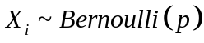，i = 1, 2,…, 20
Bernoulli p.m.f. (probability mass function) 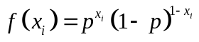
likelihood function 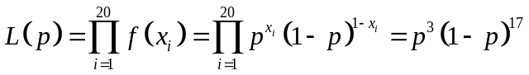

# First way: Deriving the likelihood by yourself

p <- seq(0,1,0.001)
fp <- (p^3)*((1-p)^17)
plot(p,fp,ylab='Likelihood')
abline(v=3/20)

# Second way: Building a “for” loop - likelihood is a product of p.m.f.

Lik <- function(X, p){
likelihood <- 1
for (i in 1:length(X)){
if (X[i] == 1){
likelihood <- likelihood * p
} else {
likelihood <- likelihood * (1 - p)
}
}
return(likelihood)
}
X <- c(0,0,0,0,1,0,0,0,0,0,0,1,0,0,0,0,0,1,0,0)
fp2 <- Lik(X,p)
lines(p,fp2,col=2)

- Solving the maximum likelihood estimate by hand:

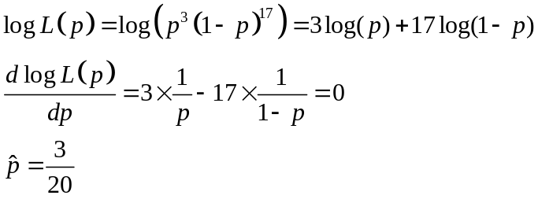

- Solving the maximum likelihood estimate by the Newton-Raphson method: (just to see if the Newton-Raphson method works in such a simple case)

Newton-Raphson method for root-finding for 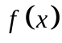:
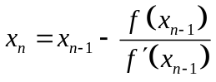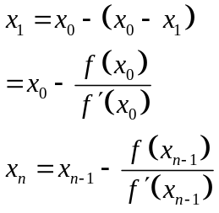

Newton-Raphson method for root-finding for 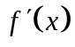:
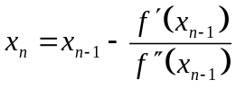

Please find the root for 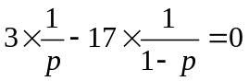. We first make a plot:
p <- seq(0,1,0.001)
fp <- (3/p)-(17/(1-p))
plot(p,fp)

We then write a function to incorporate 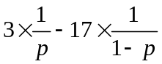 and its first derivative:
ftn <- function(p) {
fp <- (3/p)-(17/(1-p))
dfp <- (-3)*(p^(-2))-17*((1-p)^(-2))
return(c(fp, dfp))
}
newtonraphson(ftn, 0.2, 1e-06)

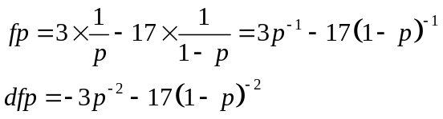

[Poisson distribution] Ex 18：A doctor observed seizure counts of 10 patients within 2 months, as follows: 3,1,2,0,6,8,4,5,7,0.
- Please plot the likelihood function for mean seizure count, . (by Second way: Building a “for” loop - likelihood is a product of p.m.f.)
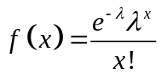

- Please plot the log-likelihood function for mean seizure count, . (Hint: 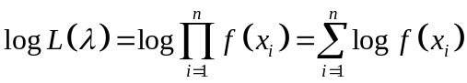 )
- Please solve the maximum likelihood estimate (MLE) of by hand, and by the Newton-Raphson method, respectively. And mark the MLE on the above two plots.

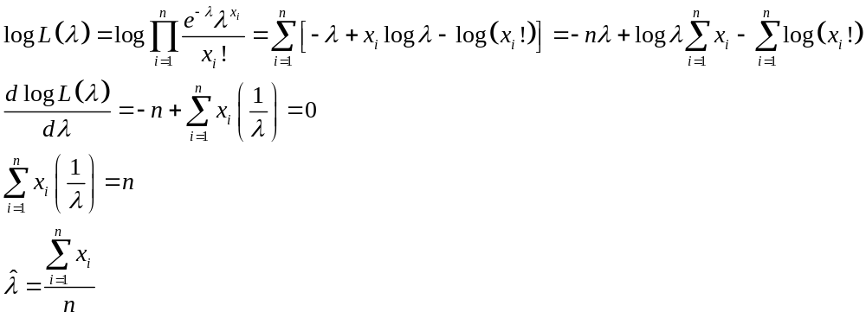

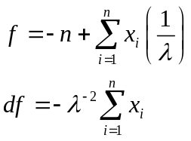
[Normal distribution] 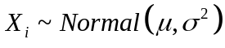，i = 1, 2,…, n
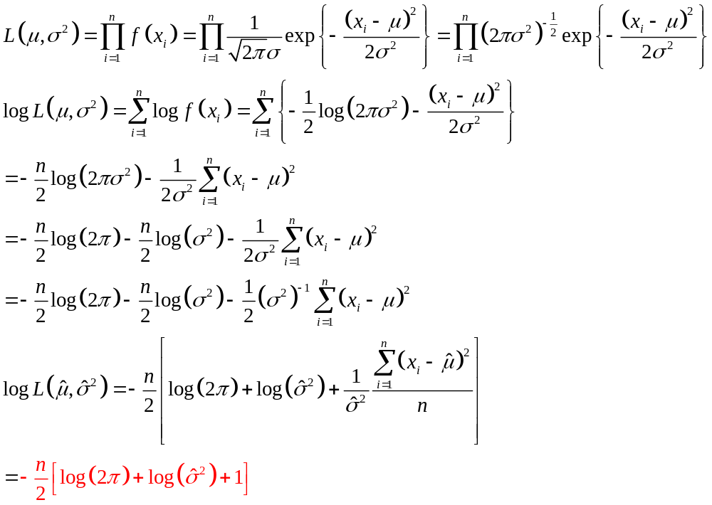
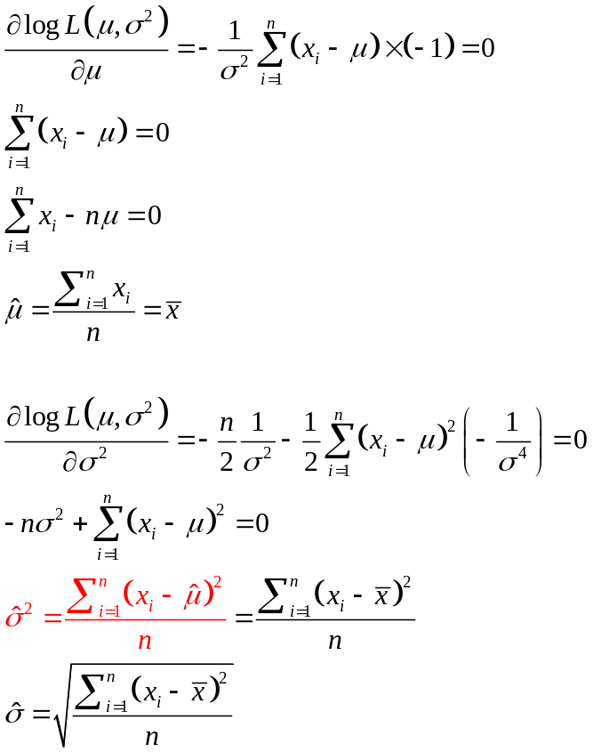
- MLE of standard deviation
Sample standard deviation 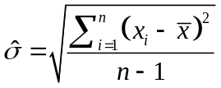
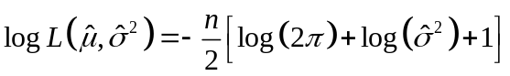 log-likelihood at the maximum likelihood estimate
(that is, the maximum log-likelihood)

logLikFun <- function(datapoint, param){
mu <- param[1]
sigma <- param[2]
return(sum(dnorm(datapoint, mean = mu, sd = sigma, log = TRUE))) ### log Likelihood of normal distribution
}
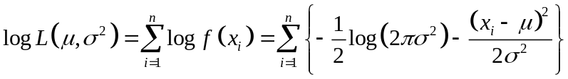

mu <- seq(70,75,0.01)
sigma <- seq(11,15,0.01)
LL <- matrix(NA,length(mu)*length(sigma),3)
X <- c(57,65,53,70,78,56,85,92,66,78,74,82,89,96,66,68,72,75,79,91,84,85,81,58,74,70,62,56,84,65)

cc <- 1
for(i in 1:length(mu)){
for(j in 1:length(sigma)){
LL[cc,] <- c(mu[i],sigma[j],logLikFun(X, c(mu[i],sigma[j])))
cc <- cc+1
}
}

library(scatterplot3d) ### install.packages("scatterplot3d")
scatterplot3d(LL[,1],LL[,2],LL[,3],xlab="mu",ylab="sigma",zlab="log Likelihood", highlight.3d=TRUE)

Ex 19：If you observed 10 young women with BMI: 21.5,16,19,20,21.5,18.6,19.3,21.1,23.5,21.3, please plot the log Likelihood by assuming the BMI follows a normal distribution.

[Likelihood of a general linear model]

Recall Ex S5: Data: seizure.csv
(1) Please use trt, age, ltime as predictors, y as the response variable, to find the regression coefficients. Please also compare your results with the results based on R built-in function “lm”.

(2) Please calculate residuals, and compare your residuals with the residuals based on R built-in function “lm”.

(3)Please calculate the log likelihood of the model in (1) (named “model1”), and compare your result with the R built-in function “logLik(model1)”.

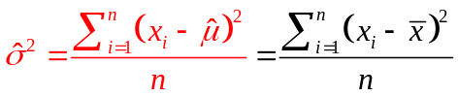 (this is the formula on page 4)
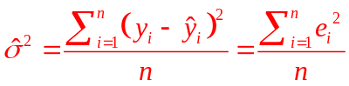

The normal distribution is now assumed on the response variable (y), so we change 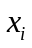 to 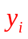.
When we have no predictors, we have no choice but use to estimate . However, in this linear model, we have three predictors: trt, age, and ltime. The predicted value 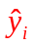 will be a better estimate of than . Therefore, .

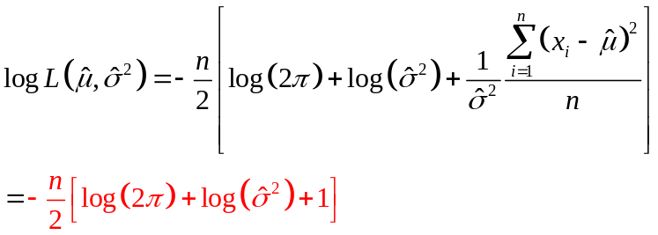

Homework: (10 points, please pay attention to all the words in this orange box):

Ex 18_1 (5 points in total)：There are 12 complicated crossroads in this city. The numbers of car accidents at the 12 crossroads within 1 month are as follows: 5, 5, 6, 0, 1, 2, 4, 4, 3, 5, 7, 10.
- Please plot the log-likelihood function for mean number of car accidents within 1 month, . (2 points) (Hint: )
- Please solve the maximum likelihood estimate (MLE) of by the Newton-Raphson method. And mark the MLE on the above plot.
Requirements: please start from making a plot to decide an initial value (1 point), and then define your function and use our newtonraphson (2 points)

Ex S5_1 (5 points in total): Data: BMIrepeated.csv on NTU COOL (Week 4). Please use “SEX”, “AGE”, “Treatment” as predictors, “BMI3” as response variable, to calculate the log likelihood of this model.

Requirement: Please start from constructing design matrix (1 point), calculating regression coefficients (1 point), calculating residuals (1 point), estimating 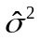 (1 point), and then using this formula: (1 point).
Please note: Using the R built-in function “logLik(model)” to answer this homework will be scored as 0, although you may use it to check your own answer.

